Input your title (Only the first word capitalized. Use Times New Roman font 15pt)

Gildong Kim¹, Michael Alphago², Robert Lastname^{1,2}
¹My Affiliation Address, My country
²His Affiliation Address, His country

This is the template for the abstract of your presentation for ICAP 2016 [1]. Do not modify the format of the document (Times New Roman font, 11pt, line spacing 110%, margins top 3cm, left 2.54cm, right 2.54cm, bottom 2.54cm, gutter 0cm, justify text) [2]. We recommend to make your abstract in a single paragraph. If you need more than one paragraph, please have 0.5cm indent as suggested below without any additional spacing between paragraphs (0 pt before and after). After editing the abstract, please convert it to a pdf format using a page setup of A4, not US letter, and submit it through the poster submission link in the conference webpage (http://icap2016.org/en/sessions/sessions.php).
This is the second paragraph. Note the 0.5cm indent. You may have a figure as shown below with a caption. Please insert a line before and after the figure. Thanks for your contribution.

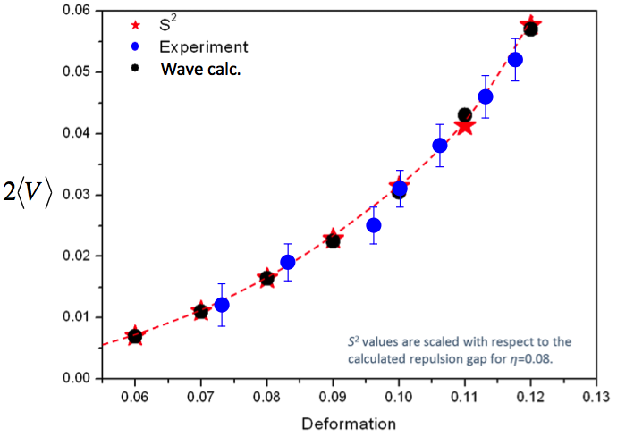
Figure 1. The figure caption begins with “Figure 1.” in bold face. No other convention is accepted. The font is also Times New Roman 11pt with a line spacing of 110%.

[1] G. Kim, M. Alphago, R. Lastname, Phys. Rev. Lett. 113, 12344 (2015).
[2] M. Alphago et al., J. of Four Sea. 13, 54321 (2014).

